Module 6: S3 Bucket Creation Assignment
S3-Bucket-Creation-Assignment-–-1
Problem Statement:
You work for XYZ Corporation. Their application requires a storage service that can store files and publicly share them if required. Implement S3 for the same.
Tasks To Be Performed:
1. Create an S3 Bucket for file storage.
2. Upload 5 objects with different file extensions

- Under S3 service Bucket General Purpose Bucket Proceed as below

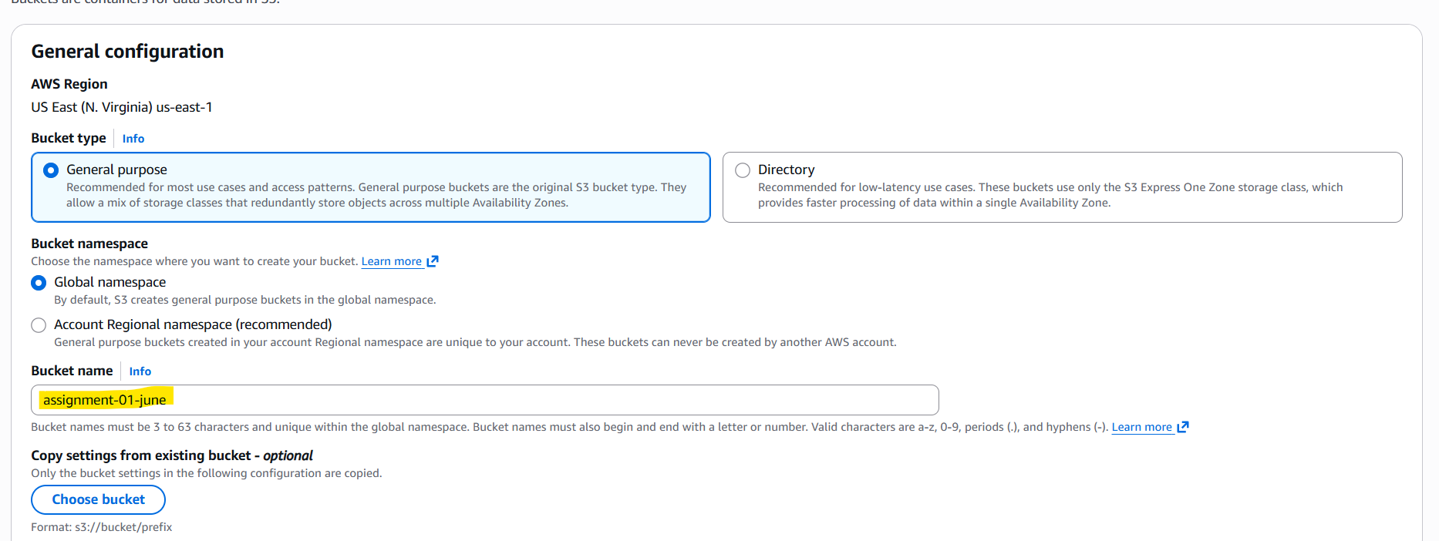

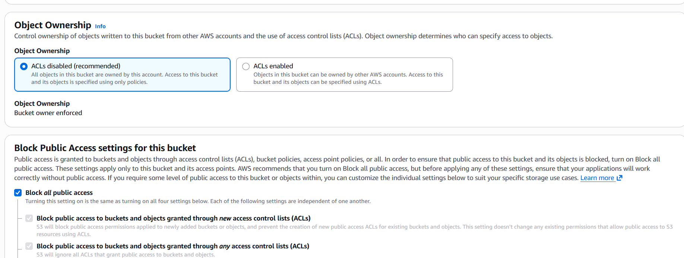
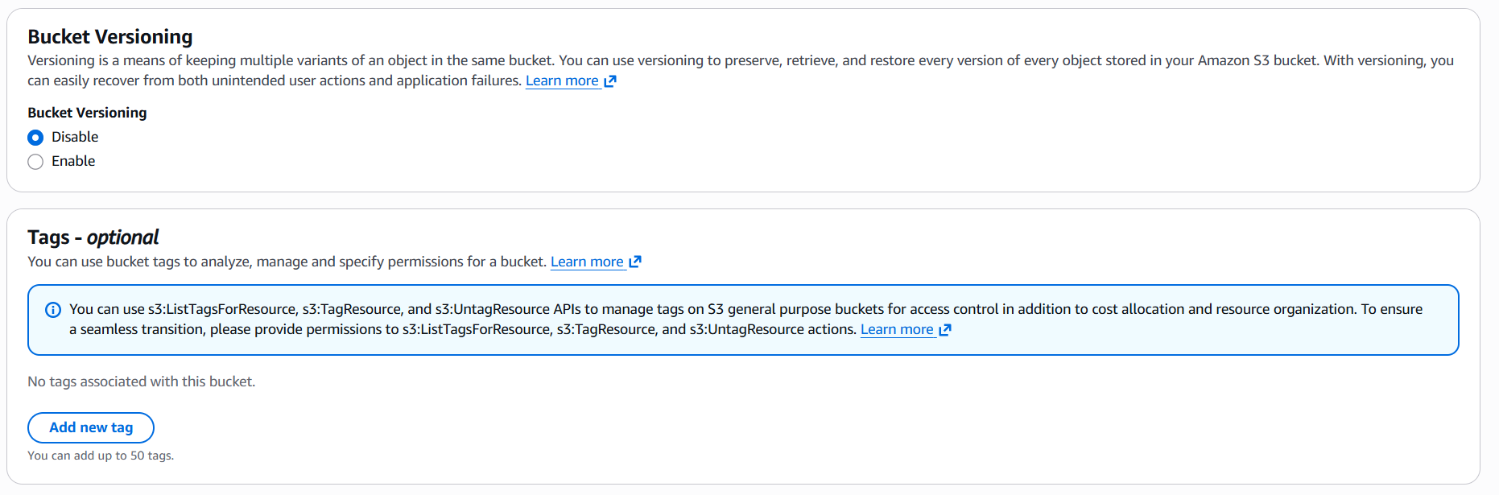

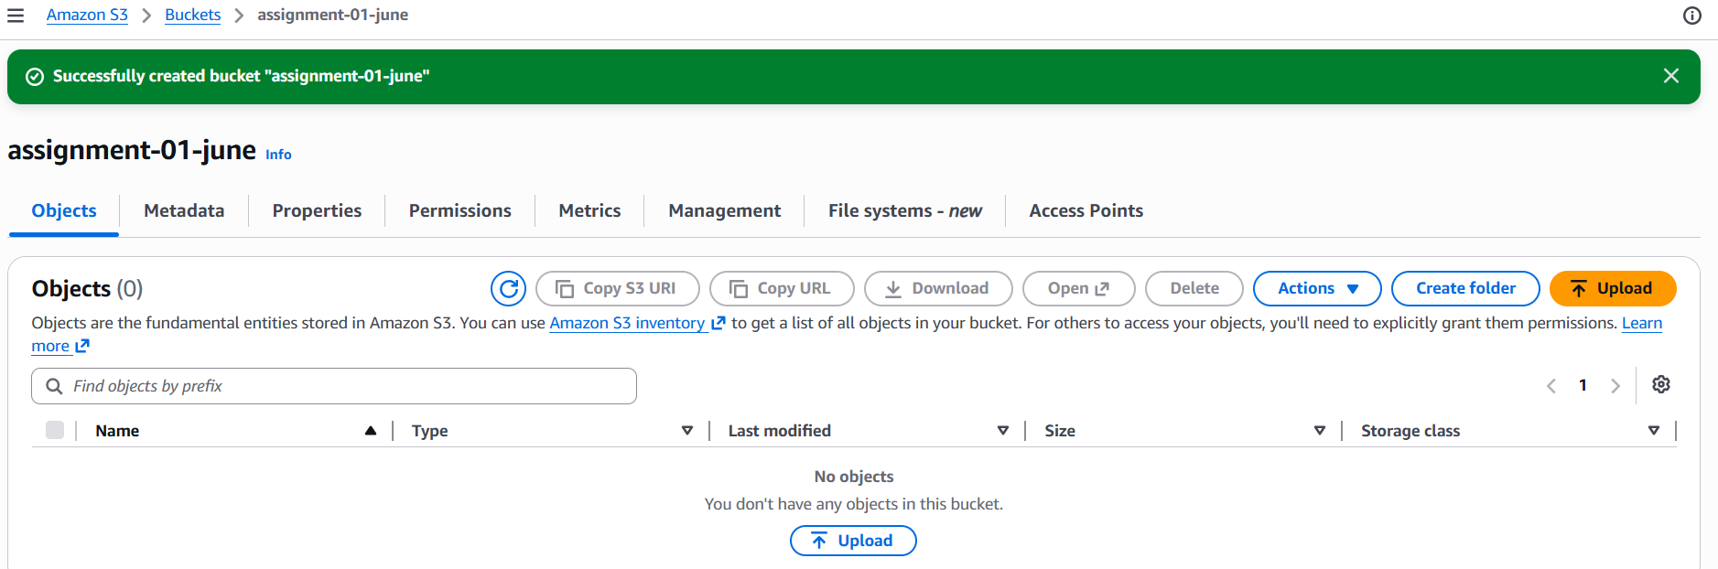

Bucket assignment-01-june is created:
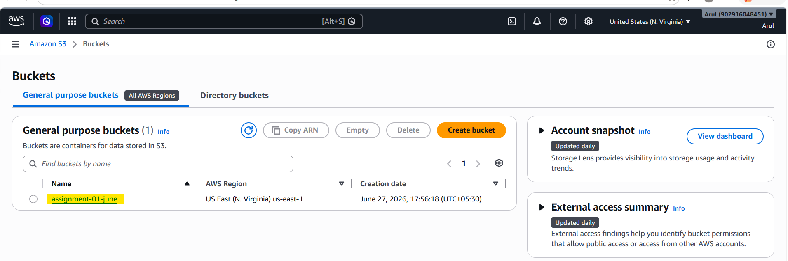

Upload 5 different objects with different extensions:
.jpeg, .txt, .pdf, .webp, .xlsx

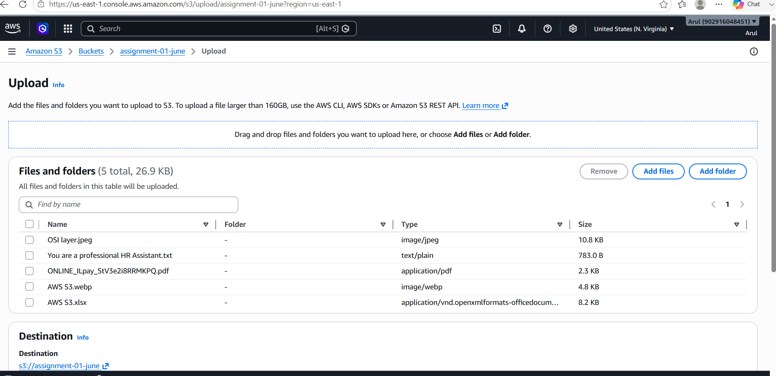

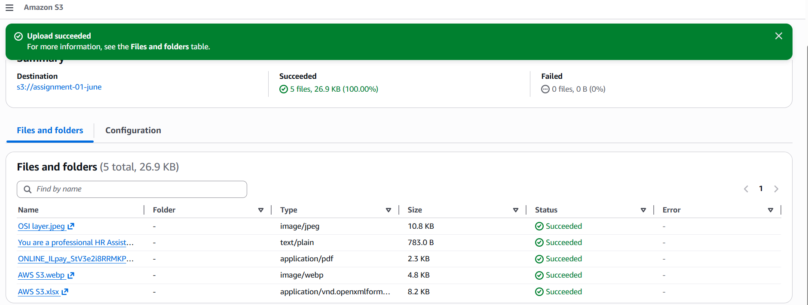

Verified the uploaded objects:

